Food Demand Prediction Using the Nonlinear Autoregressive Exogenous Neural Network
For any business growth maintaining sufficient stocks plays an important role but manufacturing over or less quantity without proper knowledge can leads to product damage, if less orders received, if more orders received then business will get affected due to insufficient quantity. To overcome from this issue author of this paper employing Novel algorithm called ‘NARXNN’ (Nonlinear Autoregressive Exogenous Neural Network).
NARXNN is a recurrent dynamic network, with feedback connections enclosing several layers of the network. The NARX model is based on the linear ARX model, which is commonly used in time-series modelling. Due to time series training propose algorithm can predict future demand with an R2 score between 97 to 99%. R2 refers to correct prediction accuracy of the regression algorithm.
In propose paper author employing NARXNN algorithm on Food Demand supply product like BREAD and Butter by collecting data from Real company and this dataset not publish on internet so we are using food demand supply dataset from KAGGLE which can be downloaded from below URL
https://www.kaggle.com/datasets/gauravsahani/food-demand-prediction-dataset
This dataset contains columns like MEAL_ID and Number of orders and by using this dataset we will train and test performance of propose algorithm.
In below screen displaying dataset details
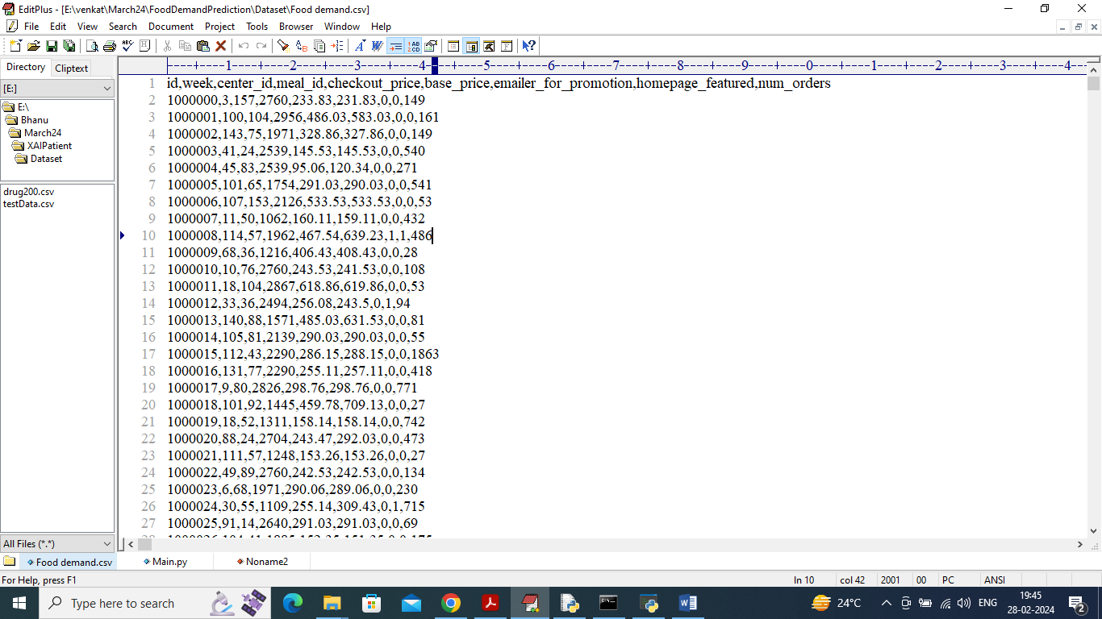
In above dataset screen first row contains dataset column names and remaining rows contains dataset values and in above dataset we have food column as ‘Meal-id’ and ‘number of orders’ column as the demand.
To implement this project we have designed following modules
- Upload Food-Demand Dataset: using this module will upload dataset to application
- Pre-process Dataset: using this module will clean dataset by removing missing values and then normalizing
- Train & Test Split: split dataset into train and test where application will be training on all records accept last 30 records. Last 30 records will be used to predict future demand
- Train Propose NARXNN Algorithm: training data will be input to NARXNN Algorithm to train a model and this model will be applied on last 30 records to predict future demand. True demand values and predicted demand will be plot in graph and then display R2 score
- Predict Future Demand: will predict and display food demand orders for next 30 days.
In below screen showing code for propose NARXNN algorithm
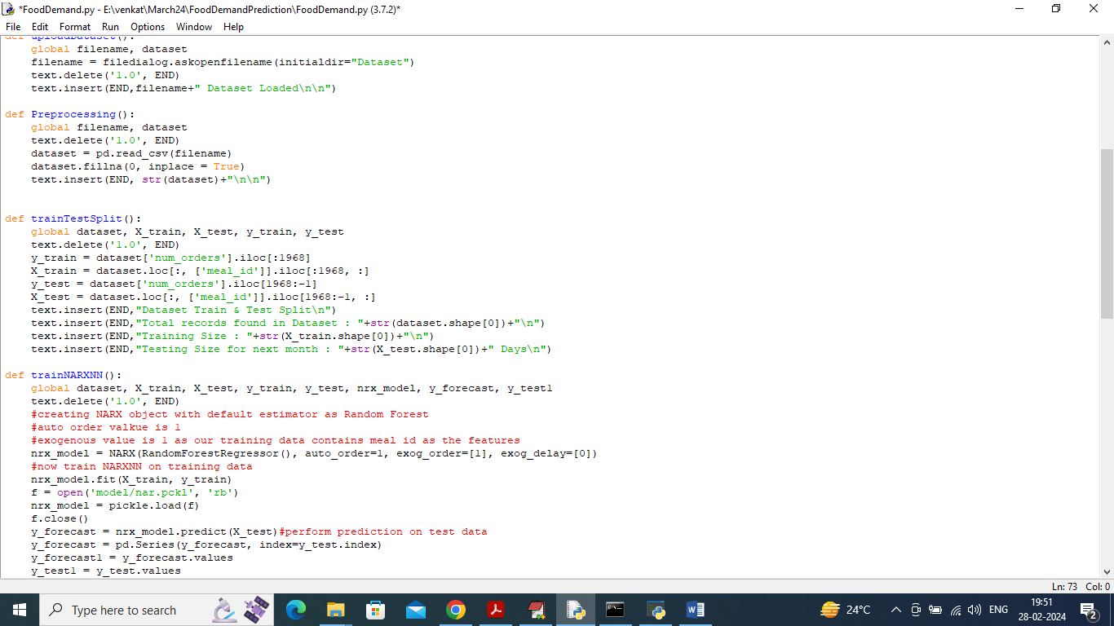
In above screen read red colour comments to know about propose NARXNN algorithm.
SCREEN SHOTS
To run project double click on run.bat file to get below screen
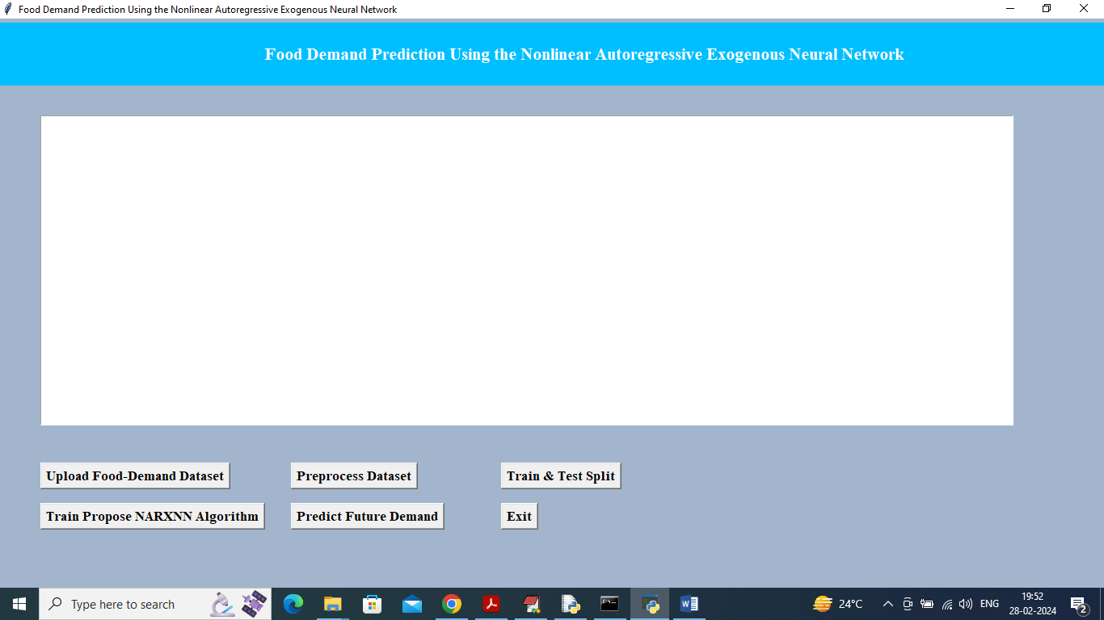
In above screen click on ‘Upload Food Demand Dataset’ button to upload dataset and get below output
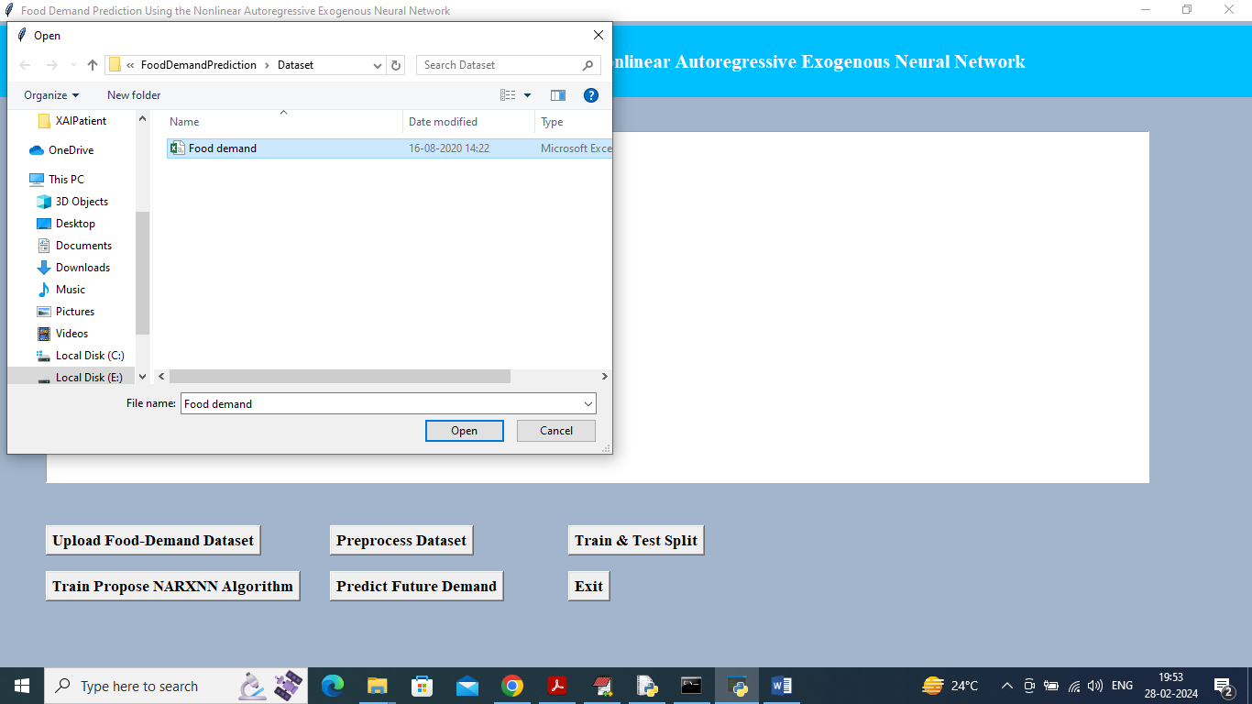
In above screen selecting and uploading Food Demand dataset and then click on ‘Open’ button to load dataset and get below page
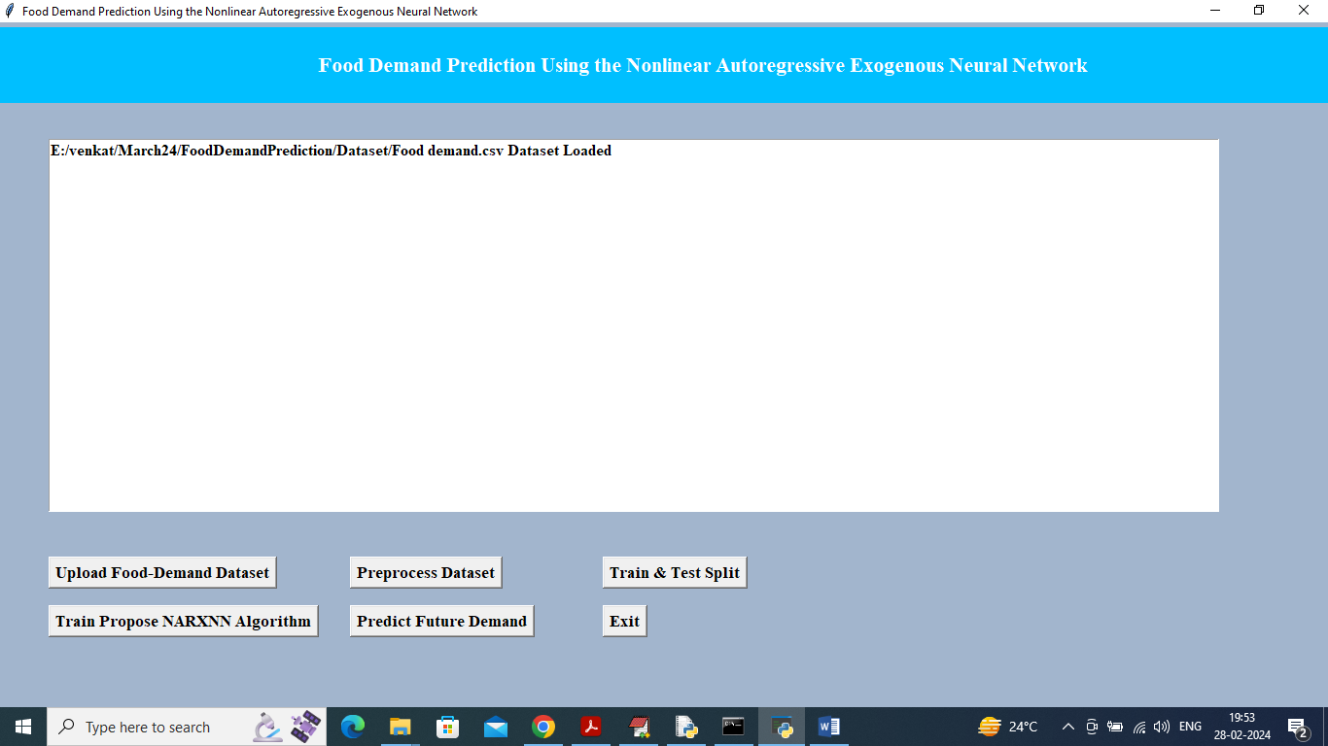
In above screen dataset loaded and now click on ‘Pre-process Dataset’ button to clean and display process dataset
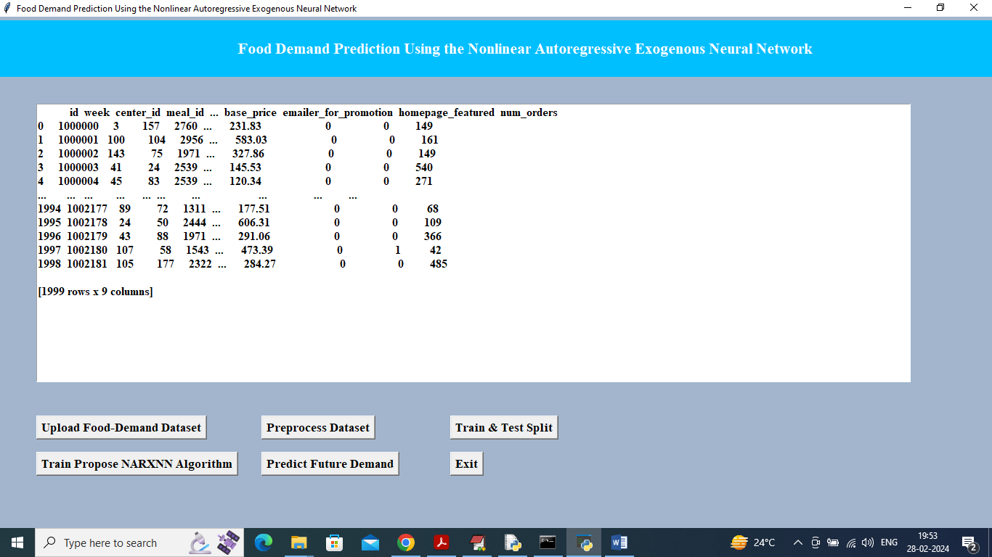
In above screen displaying processed and clean data and now click on ‘Train & Test Split Data’ button to split dataset and get below output
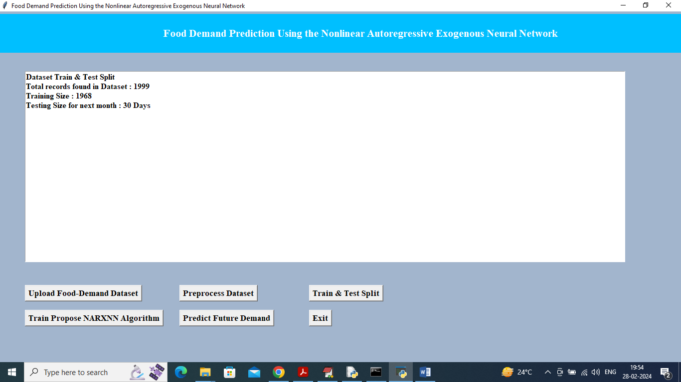
In above screen can see dataset total size and then can see training and testing size and now click on ‘Train Propose NARXNN Algorithm’ button to train model and get below output
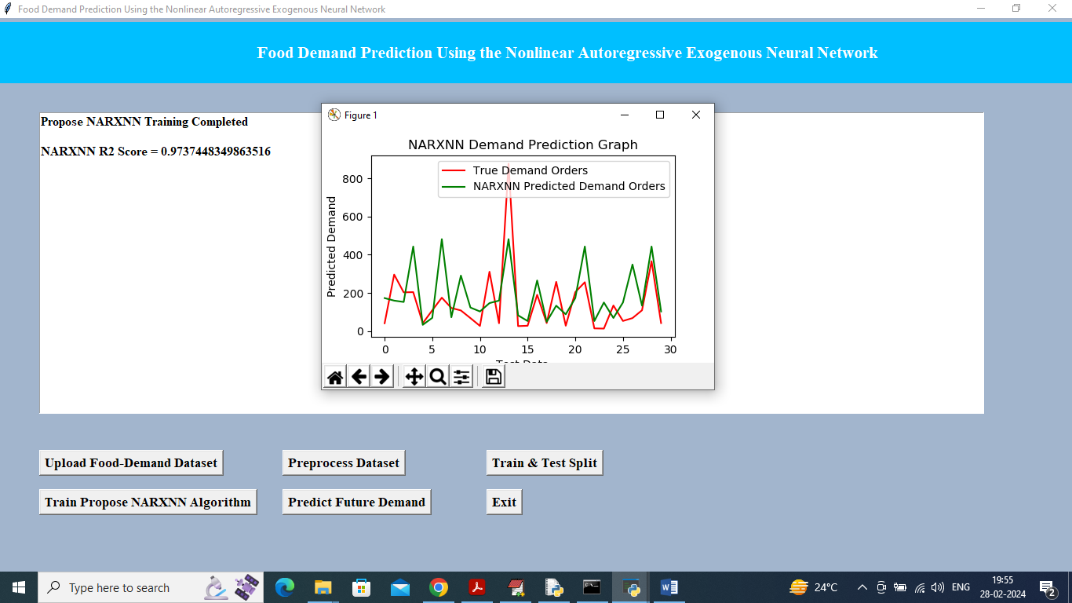
In above screen propose algorithm got 97% accuracy and in graph x-axis represents Number of Days and y-axis represents Food Demand Order and then red line represents True test data demand and green line represents Predicted demand. In above graph can see both red and green line overlapping with little gap so can see propose NARXNN prediction is accurate and now click on ‘Predict Future Demand’ button to display orders for next 30 days
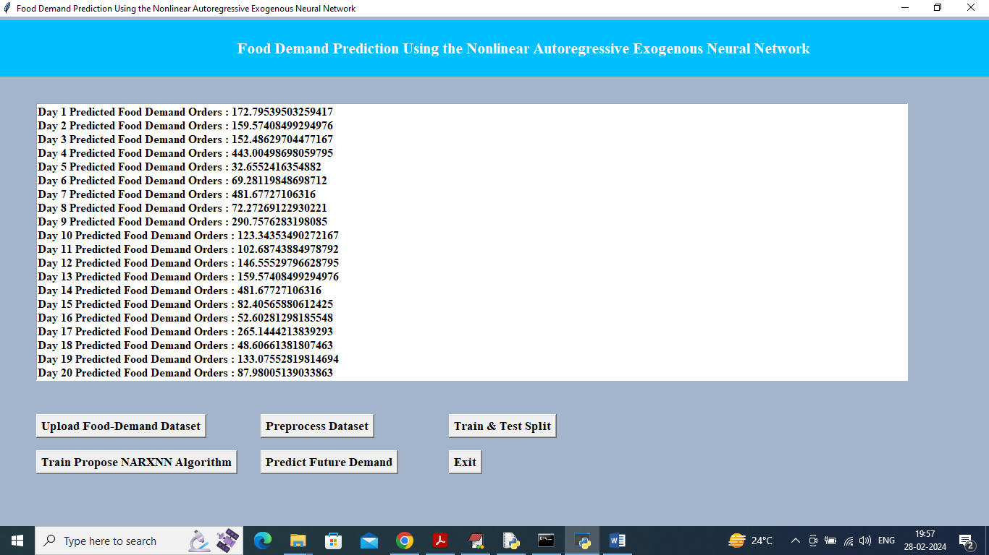
In above screen can see future demand supply orders for next 30 days.
So by using propose NARXNN model we can forecast future demand with an accuracy of 97 to 99%.

